

Subscribe to DeepL Pro to edit this document.  
Visit [www.DeepL.com/pro](https://www.deepl.com/pro?cta=edit-document)for more information.

NATIONAL AUTONOMOUS UNIVERSITY OF MEXICO

ENGINEERING FACULTY

ELECTRICAL ENGINEERING DIVISION

COMPUTER ENGINEERING

COMPUTER GRAPHICS and HUMAN COMPUTER INTERACTION LABORATORY

|  |  |  |
| --- | --- | --- |
| **TEACHER:** | ING. LUIS SERGIO VALENCIA CASTRO | |
| **GROUP:** | |  |
| **TITLE:** | | TECHNICAL MANUAL OF THE PROJECT |
| **MEMBERS:** | | **ACCOUNT NUMBER** |
| FERNÁNDEZ QUIROZ FÉLIX FERNANDO  PEREZ URIBE ANGELA ANDREA | | 315192205  316133159 |
| **DELIVERY DATE:** | | 15/09/2022 |
| **REMARKS:** | |  |
|  |

RATING: __________

**Objective.**

The student must apply and demonstrate the knowledge acquired throughout the course.

**Gantt chart.**

We use the Gantt Chart as a tool to plan the activities of a company. Its elements provide an overview of the project, as well as a follow-up of the project. It can also be useful to anticipate a problem and solve it with greater agility.

Project start date: September 13, 2022.

End of Project: December 15, 2022.

|  |  |  |  |  |  |  |  |  |  |  |  |
| --- | --- | --- | --- | --- | --- | --- | --- | --- | --- | --- | --- |
| ACTIVITY | Tuesday  Sept | Monday  Sept | Monday  Oct | Monday  Oct | Monday  Oct | Monday  Nov | Monday  Nov | Monday  Nov | Monday  Nov | Monday  5  Dec | Monday  Dec |
| The initial ideas about the project, the means of communication and the resources to be used are presented. |  |  |  |  |  |  |  |  |  |  |  |
| The initial project proposal is delivered |  |  |  |  |  |  |  |  |  |  |  |
| The first models of the house are made, the distribution of the models among the members of the team is done. |  |  |  |  |  |  |  |  |  |  |  |
| We have the models of the house as are the elements of the bedroom, bathroom, living room and kitchen, and then texturize them. |  |  |  |  |  |  |  |  |  |  |  |
| The models are imported to opengl to place them inside the scenery, as well as to give them a scale and their respective transformations. |  |  |  |  |  |  |  |  |  |  |  |
| The first animations are made within the opengl and visual studio space. |  |  |  |  |  |  |  |  |  |  |  |
| The scenario is worked to adapt it within visual studio, modifications of the models are made so that these have coherence within the space, as well as the models of the Christmas themed decorations are imported. |  |  |  |  |  |  |  |  |  |  |  |
| A group meeting is held with the team members to discuss some issues related to the project such as the audio import work inside the stage. |  |  |  |  |  |  |  |  |  |  |  |
| The user manual as well as the technical manual about the project are made. |  |  |  |  |  |  |  |  |  |  |  |
| Final Delivery |  |  |  |  |  |  |  |  |  |  |  |

**Scope of the project**

The student will have to create a virtual environment, which will represent the interior of a house with Christmas decorations.

1. The student will propose the interior space to be represented. The proposal must be submitted in advance to the teacher to get his approval before being built, considering that it must have at least 3 bedrooms, 2 bathrooms, living room, dining room, kitchen, garage, garden with pool and furniture of the same spaces.

Taking the following model as a reference

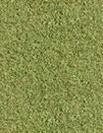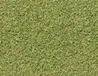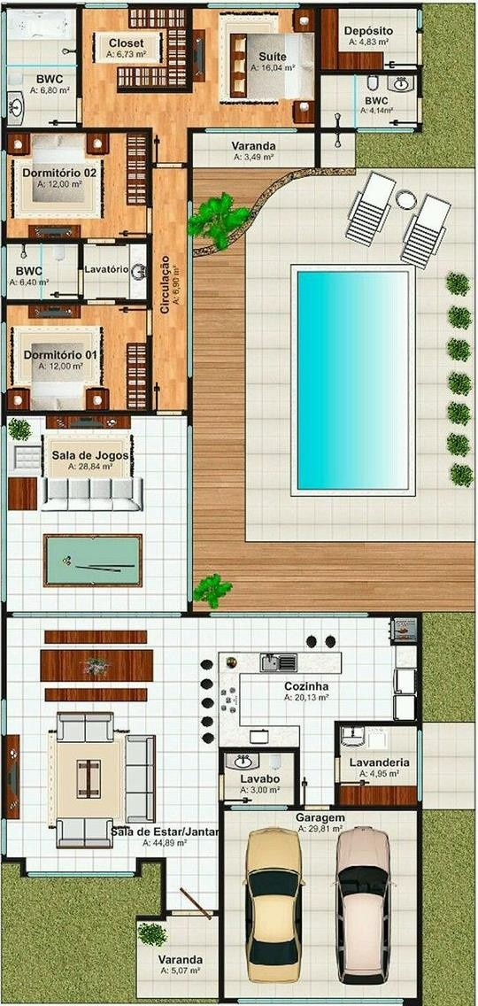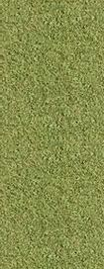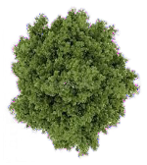

## Limitations

* The code base seen during the course and given by the teacher must be used. Modeling and animation methods different from the syllabus cannot be used.
* The delivery date is December 15, 2022 at the latest.
* For all the elements, the student will use the techniques of geometric modeling, hierarchical modeling and texturing to build the elements. Models downloaded from the internet can be used as long as they respect the licenses that they handle and the corresponding credits are given in the documentation that is delivered, indicating their origin.
* The scenery elements must have textures applied correctly.
* The student will add at least five (5) elements with different complex animations. At least one of these animations must be by the KeyFrames technique. It is up to the student to choose the objects to animate, but they must be related to the scenario that is being built. It is PROHIBITED to use animations created during the lab sessions (animations of windows, doors or fans are not considered as complex).
* It will incorporate an audio library to add background music, so the student will be required to

**Requirements analysis**

* Software
  + - Autodesk Maya
    - Blender
    - GIMP
    - Visual Studio 2019 Community

## Project cost analysis

The following considerations apply to this project:

It is considered a contract period of 13 and a half weeks which would be approximately 93 days which runs from September 13, 2022 to December 15, 2022. Although of these only 70 working days with 8 hours of work per day are considered, the rest will be mandatory rest for employees.

* Internet service $550.00 per month.
* Electricity service $150.00 per month.
* Stationery service $1,000.00 .
* Maya Software Licenses $3,087.00 per month
* 1 project leader at 50% with a salary of $400 per hour.
* 1 100% senior designer at a salary of $200 per hour.
* 1 junior programmer at 100% with a salary of $150 per hour.
* 1 senior programmer at 40% at a salary of $300 per hour.
* Computer service with a value of $17,000 with a useful life of 5 years, so it has an annual value of $3,400.

The following table is used to reflect the total cost of the project.

|  |  |  |  |
| --- | --- | --- | --- |
|  | Services | Cost per month($) | Cost per 70 days($) |
|  | Internet | 550 |  |
|  | Electricity |  | 300 |
|  | Stationery | 1000 | 2000 |
|  | Maya Software | 3087 | 6174 |
|  | Computing | 283.33 | 566.66 |
|  | Salaries | Cost per day | Cost for 70 days |
| 50% | Project Leader | 3200 | 112000 |
| 100% | Junior Designer | 1600 | 112000 |
| 100% | Junior Programmer |  | 84000 |
|  | Senior Programmer | 2400 | 132000 |
|  | Total | | 450,140.66 |

Considering the services and salaries necessary for this project, the total cost is $450,140.00 pesos.

## Code documentation.

Within the original code, there are 2 specific points where changes were made, which are detailed below:

## Declaration of each of the models

In this part of the code, each one of the models is declared with extension . obj so that they can be visualized by OpenGL, here the names are assigned with which each object or model will be identified and modified as the case may be, an example of this is shown below:

Model floor("resources/objects/floor/floor.obj");

## Drawing of the models.

In this section of the code is where some necessary aspects of each one of the models are modified so that they are shown in OpenGL, but at the same time that they have the correct position, size and rotation according to the case. An example of this is shown below:

model = glm::mat4(1.0f);

model = glm::translate(model, glm::vec3(0.0f, -1.75f, 0.0f));

model = glm::scale(model, glm::vec3(0.2f));

staticShader.setMat4("model", model);

floor.Draw(staticShader);

**Collaboration tools**

**Communication Plan**

For the development of the project, the work team has distributed information and necessary tasks through different technological tools to achieve the success of the project, and they are the following:

* Online Meetings
* Whatsapp
* Github
* Google drive
* E-mail address
* Cell phone

In order to classify the type of communication for each of the cases that arise during the project, the following table is used.

|  |  |
| --- | --- |
| Case | Type of communication |
| Whatsapp | Informal written |
| Google drive | Informal written |
| GitHub | Informal written, informal verbal. |
| E-mail address | Informal written |
| Cell phone | Informal verbal |
| Documentation | Formal written |

**Evidence of collaboration tools**

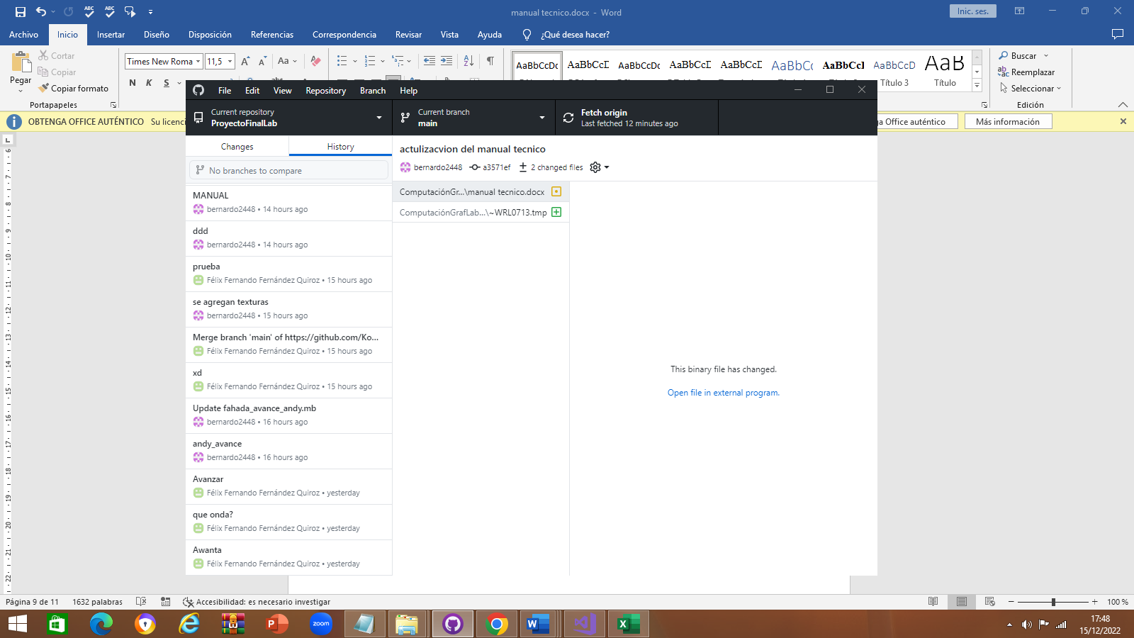

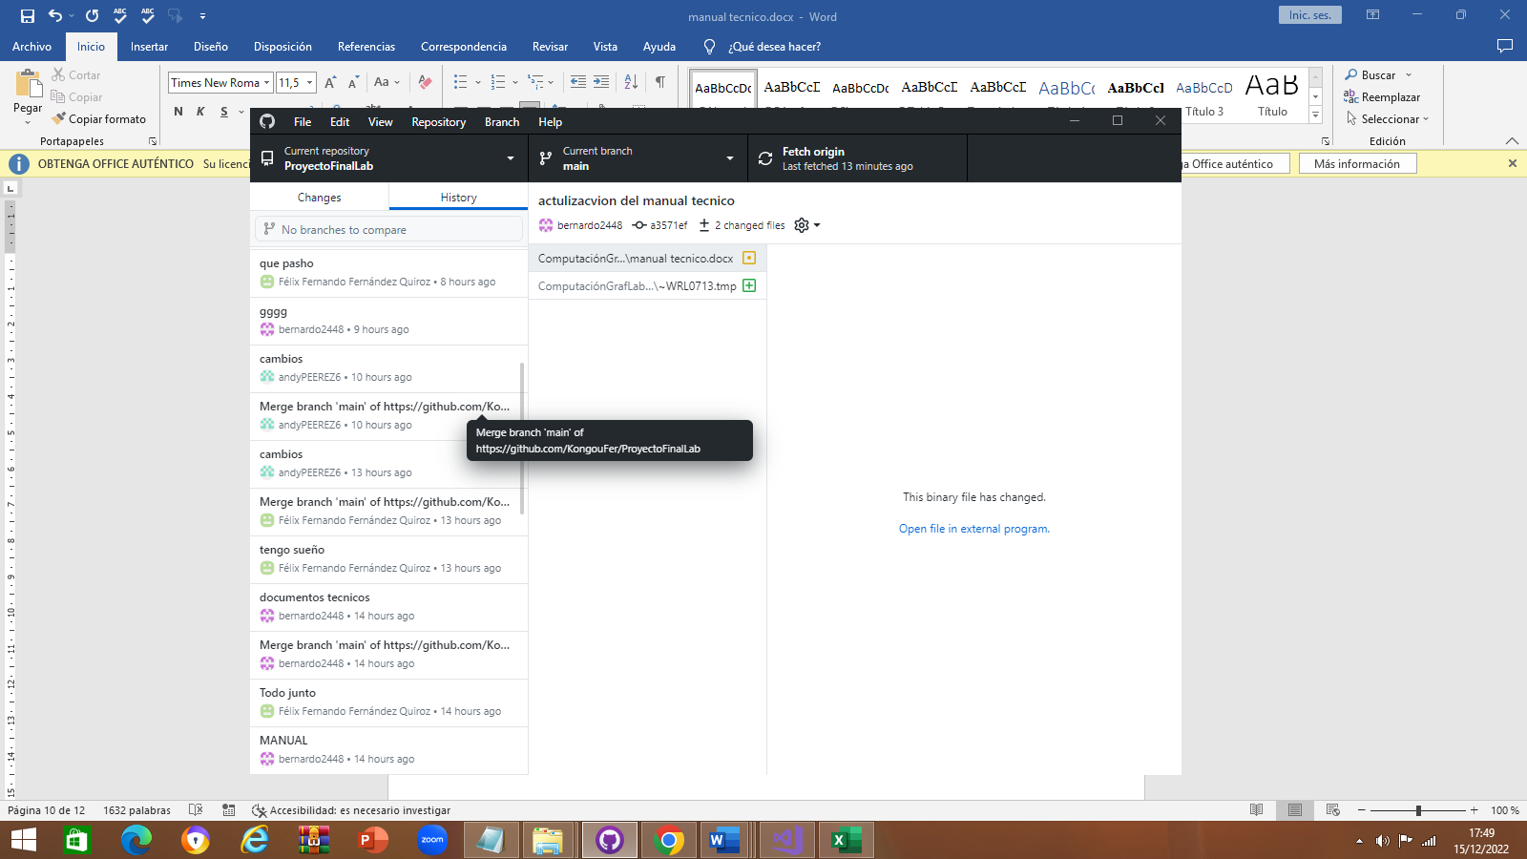

**Description of activities**

Fernández Quiroz Félix Fernando

In the course of this project I felt calmer because I already had a fundamental part of it because of the laboratory project associated with the subject of Computer Graphics, so the objectives of implementing the knowledge of the course in this project were fulfilled.

The fact of adding complementary knowledge in the project such as a work methodology or a cost analysis made the project become a project associated to reality and at the same time to remember and apply knowledge from other subjects.

Regarding the modeling of objects I did the part of the garage, the living room, the dining room, and the kitchen, as well as I added the models related to the Christmas theme that was requested as guidelines for the project, with this I realize that the modeling of objects was really easy because the Maya software provides many tools to export these models.

One of them is that once we had all the models separated in maya, what I did was to import all the models into the same file in maya so that everything would be exported as a whole when we moved it to visual studio, except those models that were going to have animations like the trunk, the dresser, the train and the garage door.

Once the modeling was finished, regarding the animations I made the part of the christmas train that circulates around the room of a part of the house, I also added an animation of the human that moves in all directions.

In addition, I also added the animation of the garage that moves up and down, also from the modeling I made the skeleton of the house, as well as the pool and the places around and finally worked the scenario itself that started from the code work in each class with the teacher.

Finally to work in the field of animations was done with external libraries for the example of adding background music to the stage, the fact of working with animations in the project gave rise to investigate some ways to move objects, really the practices made in the course were helpful because I based on some of the practices and their operation to animate the models within the scenario, I would have liked to work with positional lights within the scenario but due to time issues was not reached, but I feel really satisfied with the project.

Pérez Uribe Angela Andrea

For the realization of the project first decided on what model will work taking into account the requirements of the project, such as rooms, bathrooms, the type of animations that should have the work, which is why in the end to deliver the prototype of the project has a scheme on which we rely for the realization of the modeling.

With reference to the modeling the partition of activities was half of the scenario corresponded to me and the other half to my partner, that's why my models were all the bathroom, the rooms, the closet, the trash can, the toilet, the tub with the key, the picture of flowers, the furniture, as well as I was in charge of the textures of these models.

Regarding the animations that were requested in the work I was in charge of the animation of the trunk that opens with some keys, as well as the animation of the touch with drawers in which pressing a key automatically opens the drawers.

With the completion of the project I can realize the complexity of modeling, being honest the project cost me a lot of work because I had never modeled any object so at first I did not know where to start, I started watching some tutorials on the internet about the installation of Maya as my partner told me it was the most intuitive software for the user, once I had installed Maya I dedicated myself to watch tutorials from the most basic as they are the commands to move within the modeling software.

Once I learned some basic commands, I started from models that work from a square or a sphere, which is why many times the models found on the internet are based on the most basic geometries that exist, once I finished modeling, I set out to texture the models the truth at first cost me a lot of work because the practice in which I address the issue was not clear is why when I exported the obj not exported me with everything and images that occupies and exporting it to visual studio was not appreciated correctly models with textures.

Another difficulty I went through was exporting them to visual studio because I did not know how to export in obj these models worked, which is why I had to make constant video calls with my partner to explain me what I had to do, Another important aspect was to work with GitHub I had never worked with this tool before so I did not know how to use it, but with this project I realized that it is really very easy to use as well as its visualization because we do not need to constantly share folders or files by mail because we can directly make a coommit in GitHub.

**Copyrighted characters (either as model or texture):**

* Korone Inugami of Hololive Production and Cover. Inc
* Anya Forger from SPY X FAMILY Franchise by Wit Studio, CloverWorks, Shonen Jump and Tatsuya Endo
* SpongeBob from the SpongeBob franchise owned by Nickelodeon and Viacom.

**Models**

Turbosquid:

* Sofa - CarCus Creation (2011) URL: https://www.turbosquid.com/es/3d-models/free-3ds-model-basic-couch/587657#
* Chair - HuNtEr_3DdD (2021) URL: https://www.turbosquid.com/es/3d-models/3d-wooden-stool-lowpoly-model-1806860

Sketchup:

* CC-Attribution License
  + "Inugami Korone (hololive)" (https://skfb.ly/ooK8s) by chained_tan is licensed under Creative Commons Attribution (http://creativecommons.org/licenses/by/4.0/).
  + "Armchair" (https://skfb.ly/6SRpC) by IssaMaia is licensed under Creative Commons Attribution (http://creativecommons.org/licenses/by/4.0/).
  + "Toy Train" (https://skfb.ly/ovKpr) by MaX3Dd is licensed under Creative Commons Attribution (http://creativecommons.org/licenses/by/4.0/).
  + "Christmas Tree" (https://skfb.ly/6uxwH) by jameshealey94 is licensed under Creative Commons Attribution (http://creativecommons.org/licenses/by/4.0/).
  + "Stylized Gift Box Free Download" (https://skfb.ly/ouBn9) by zack424 is licensed under Creative Commons Attribution (http://creativecommons.org/licenses/by/4.0/).
  + "Milk And Cookies" (https://skfb.ly/6WVIy) by ion_omat is licensed under Creative Commons Attribution (http://creativecommons.org/licenses/by/4.0/).
  + "Cute Kitchen Oven" (https://skfb.ly/oppT9) by Coco Jinjo is licensed under Creative Commons Attribution (http://creativecommons.org/licenses/by/4.0/).
  + "Candy Cane Cutter" (https://skfb.ly/DVFC) by Microsoft is licensed under Creative Commons Attribution (http://creativecommons.org/licenses/by/4.0/).
  + "Gingerbread Snowglobe Garland" (https://skfb.ly/oAvuE) by Artistjodi is licensed under Creative Commons Attribution [(](http://creativecommons.org/licenses/by/4.0/)http://creativecommons.org/licenses/by/4.0/).
* CC-Attribution-ShareAlike License
  + "Fridge Asset - Home Appliances" (https://skfb.ly/6UZGz) by Alstra Infinite is licensed under Creative Commons Attribution-ShareAlike (http://creativecommons.org/licenses/by-sa/4.0/).

**Textures**

* Freepik (Free License)
  + https://www.freepik.es/vector-gratis/papel-tapiz-abstracto-blanco-diseno-papel-3d_6345412.htm#query=papel%20tapiz&position=2&from_view=keyword
  + https://www.freepik.es/psd-gratis/muebles-cocina-moderna_7045765.htm#query=muebles%20cocina&position=0&from_view=keyword
  + https://www.freepik.com/free-photo/garage-door-texture_4140728.htm#query=garage%20door%20texture&position=11&from_view=keyword
* iStock
  + Leszek Kobusinski - https://www.istockphoto.com/es/foto/textura-de-fieltro-verde-para-el-poker-y-el-fondo-del-casino-gm1133423137-300816310
* Kitchen furniture - https://decoracion.trendencias.com/cocina/17-cocinas-que-demuestran-que-mezclar-muebles-acabados-cocina-exito
* Sketchup Texture Club - https://www.sketchuptextureclub.com/
* BLUES ABSTRACT MIX LUX - Cerâmica Portinari www.pinterest.com.mx/pin/348254983698980332/